CS 340 README Template

About the Project/Project Title
This project is a full-stack Python dashboard application that connects to a MongoDB database and allows users to interact with the Austin Animal Center dataset. The dashboard enables users to filter and visualize data to identify dogs suitable for different types of rescue operations for Grazioso Salvare.

Motivation
The goal of this project was to extend the CRUD module developed in Project One into a fully functional dashboard. This demonstrates how backend database logic integrates with a frontend interface, allowing users to analyze and visualize data efficiently.

Getting Started
1. Import AAC dataset into MongoDB (aac database, animals collection)
2. Create user 'aacuser' with read/write access
3. Use the AnimalShelter.py CRUD module
4. Run ProjectTwoDashboard notebook to launch the dashboard
5. Use filters to interact with the data

Installation
• MongoDB – stores the data
• PyMongo – connects Python to MongoDB
• Dash (Plotly) – builds the dashboard UI
• Jupyter Notebook (Codio) – runs the project
• Python – core programming language

Usage
The dashboard includes:
• Interactive data table with sorting, filtering, and pagination
• Radio button filters for rescue types (Water, Mountain/Wilderness, Disaster/Tracking)
• Pie chart showing breed distribution
• Geolocation map displaying animal locations
Users select a filter to update all components dynamically.

Code Example
# Example filter usage
filter_type = 'water'
results = db.read({"animal_type": "Dog"})
print(results)

Tests
The dashboard was tested in Jupyter Notebook. Filters were applied and verified to update the table, chart, and map correctly. Screenshots were taken for each required filter state (Reset, Water, Mountain/Wilderness, Disaster/Tracking) to confirm functionality.

Screenshots
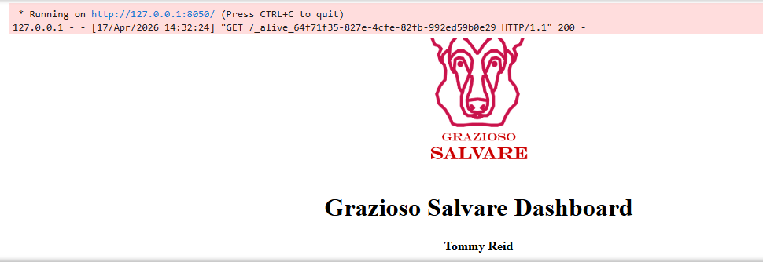
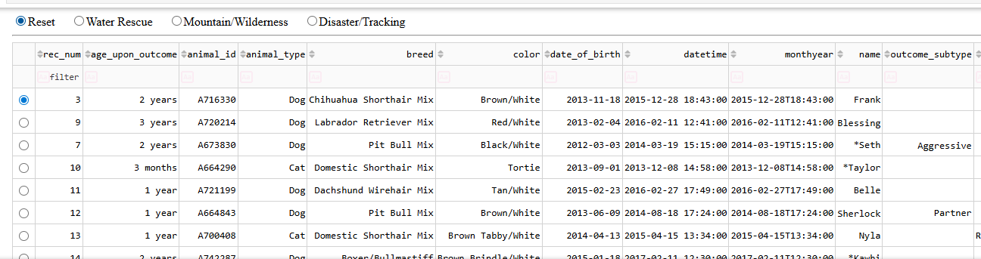

- Water Rescue
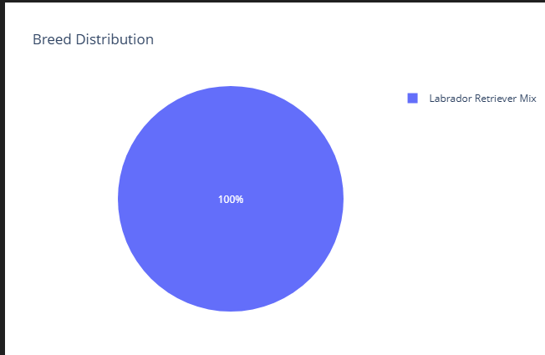

- Mountain/Wilderness
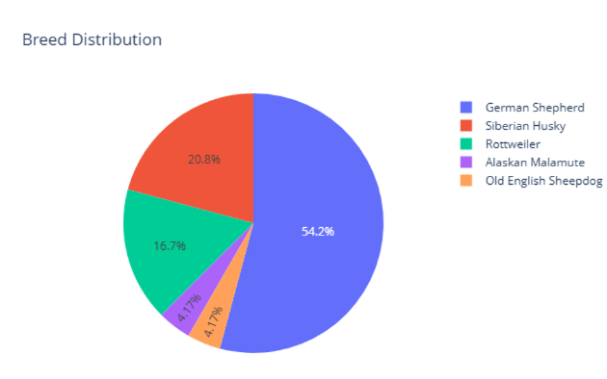

- Disaster Tracking
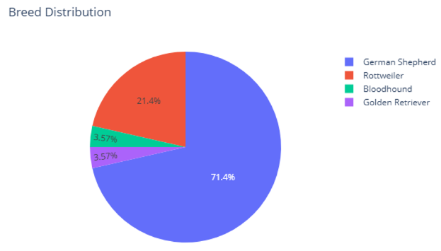

- Reset
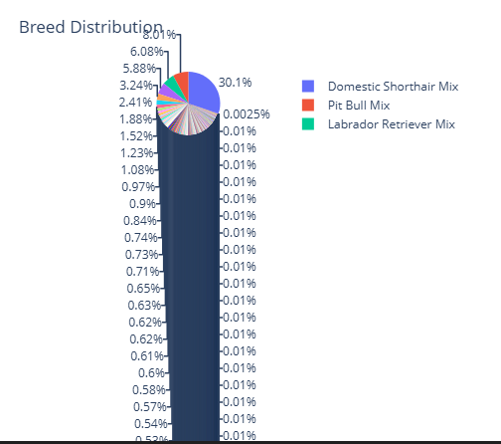

- Map
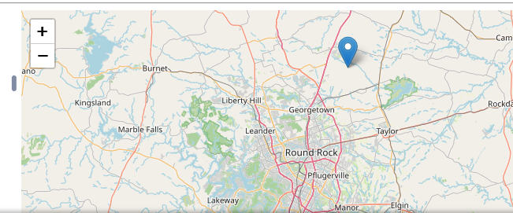

Contact
Tommy Reid

